Abstract Title

Author A ^{1,2}, Author B ¹, and Author C²
¹Research Center for Ubiquitous MEMS and Micro Engineering (UMEMSME),
National Institute of Advanced Industrial Science and Technology (AIST),
1-2-1 Namiki, Tsukuba, Ibaraki 305-8564, JAPAN
²Graduate School of Frontier Sciences, The University of Tokyo,
5-1-5 Kashiwanoha, Kashiwa-shi, Chiba 277-8563, JAPAN

Abstract

The International Conference on BioSensors, BioElectronics, BioMedical Devices, BioMEMS/NEMS & Applications (Bio4Apps 2017) will be held December 11-13, 2017 in Tokyo, Japan. Authors are invited to contribute your work for either oral presentation. Please submit your abstract in both MS WORD (*.doc) and PDF files.

As the conference proceedings will be published in A4 format, it seems advisable to set up the layout on your PC/Mac/workstation in this format. A4 paper is 29.7 cm high and 21 cm wide (or 8.27 inches x 11.69 inches). In this format, define 1.5 cm (.60 inches) wide left and right margins, a 2.5 cm high top margin (1 inch) and a 3 cm (1.20 inches) bottom margin. The title/author/affiliation section should be centered above both columns.

Please use Times New Roman throughout the entire manuscript, from title, authors, affiliation, and headers, to figure and table captions, and references. The length of the abstract, including reference and author biography, can vary from 1 to 2 pages. To achieve as unified a look across the proceedings as possible, the following formats are preferred for the main paragraph types, as illustrated also by this sample manuscript:
• Title: 16 points, bold;
• Authors: 12 points, bold italic;
• Affiliation: 12 points, regular;
• Street, City, STATE/Province,
COUNTRY: 12 points, regular
• Text body: 12 points, regular;
• Figure captions: 10 points, italic;
• Table captions: 10 points, italic;
• The font size of references is 10 points, regular, numbered in [ ].
Each figure should be accompanied by a numbered caption, as shown in Figure 1, placed directly below the figure being described. All labels within the figure frame should be in font 9 points or larger.

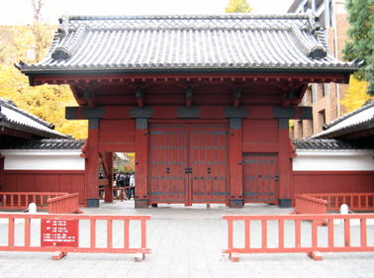
Figure 1. Akamon Gate

Table 1. Sample of a Table Format
Table Head | Table Column Head
Table Head | Table Column Subhead | Subhead | Subhead
Copy | More table copy

Tables should be preceded by a caption. Table 1 illustrates a possible design with 12 points font size.

Reference

[1] S. Takamatsu, T. Lonjaret, E. Ismailova, A. Masuda, T. Itoh, G. G. Malliaras, “Wearable Keyboard Using Conducting Polymer Electrodes on Textiles”, Advanced Maerialst., Vol. 28, 4485-4488 (2016).

Author biography

The presenting author (typically the first author) is encouraged to provide a short biography (approximately 100 to 200 words.) There is no need to provide author’s photograph.

